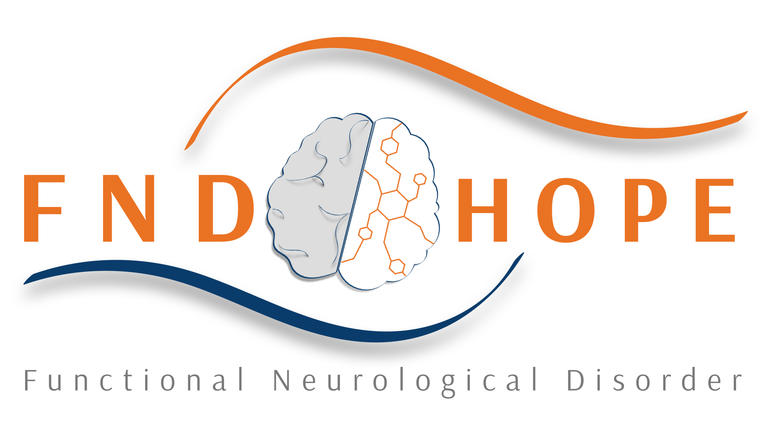

The following is written by Dr. Mark Edwards.

Many thanks to everyone for submitting their questions. I can fully understand the urgency that some people conveyed in their questions for information about this condition: it can be very disabling and there is quite limited information out there to help people understand what is happening to them.
I have grouped the questions into three different categories which seemed to me to asking about specific aspects of FND: 1) Do I have FND? 2) Why did this happen to me? 3) Can I get better?
Do I have FND?
This is the most difficult of the issues raised to address, because as you can imagine, FND cannot be diagnosed without physically seeing, talking to and examining a person, and sometimes also having access to specific test results. I am sorry therefore to those of you who wrote asking if your specific symptoms could be due to FND: this is not a question that I am in a position to answer.
What I can try to do though is to explain how the diagnosis should be made. This is a diagnosis that should, where at all possible, be made on the basis of positive features that are gathered by the doctor during history taking (i.e. talking to the patient about their symptoms and how they have developed) and during physical examination. There are some other positive features that can be revealed during certain investigations.
Let me give you some examples. A person may have developed sudden onset of weakness down one side of the body. The most likely explanation for this is a stroke, but let us assume that a good quality MRI scan of the brain and spinal cord is normal. This does not automatically mean the person has a functional weakness, although it is quite likely as it is quite hard to think of neurological diseases that could cause a weakness like this without any abnormalities on the scan. The
diagnosis of FND is actually made by examining the person. In the examination the person will not be able to move the weak leg, but when they are asked to make a hip flexion movement with the good leg, the doctor will be able to feel that the power in the weak leg comes back. This is a sign called “Hoover’s sign”. It shows that movement is possible in the weak leg (i.e. all the basic wiring is working), but the person’s access to it voluntarily is not normal. This is a fundamental property of functional symptoms: “wiring” that is normal and can be revealed to be working when movement happens “automatically”, but an inability to make things work when the person is consciously trying. You, I hope, see the point about how the diagnosis of FND should be made – normal tests can be helpful in ruling things out, but in the end one should be looking for positive features to make the diagnosis securely.
Another example is a person with what look like epileptic seizures. A person with this problem might have episodes where they collapse and shake and are apparently unconscious, although they might retain some awareness of what is going on around them but be unable to respond to people. Let’s imagine that the shaking attacks can last on and off for up to 2 hours. Here, the diagnosis of a functional “non-epileptic attack” comes from the description of the attack. We know from years of study of patients with epilepsy that epileptic attacks rarely last more than a few minutes, and when they do (as in epileptic “status”) prolonged attacks often lead to brain damage and even death. In addition patients with prolonged attacks of epileptic seizures never retain awareness during an attack. The person I am describing here might go on to have a brainwave recording (EEG) hoping to record brainwaves during attacks. In functional non-epileptic seizures, these recordings will show a pattern of brainwaves that is usually seen when people are awake and functioning normally, despite what the person is experiencing. So here the combination of positive features on the history and a specific investigation (which is actually not always necessary to make this diagnosis) have worked together to make a positive diagnosis.

There are situations where things are more complicated. For example, in people who experience pain or numbness or fatigue it can be hard to gather as much positive evidence to make a positive diagnosis of FND. Here one is often in the situation of trying to prove that the basic sensation wiring is normal (this can be done with electrical tests), making sure that other tests are normal, and thinking about whether the pattern of loss of sensation or pain could fit with what we know about the basic way in which the nervous system is wired up. In this way one can come to a decision that a functional sensory problem is most likely.
You will see that I have not made any mention of psychological factors so far in the description of how the diagnosis is made. This is because there is no good evidence that psychological difficulties MUST be present in people with FND. It is also the case that many people with neurological disease, particularly when it affects the brain, will have psychological problems (which makes sense when you realise that the mind and the brain are the same organ). For this reason, I would never make the diagnosis of FND just because a patient presents with a neurological symptom and is depressed/anxious/suffered emotional traumatic events. By saying this, I am NOT saying that psychological factors are unimportant for some people with FND, just that they are not the way in which the diagnosis should be made. More on this below.
This discussion about the diagnosis shows that it requires attention to detail, expertise and skill. The good news is that, on the whole, neurologists do seem to get the diagnosis right. So, in studies which have looked at how often the diagnosis of FND is changed at long-term follow up, this happens in only 1-5% of patients. If this sounds like a lot, then it is useful to know that when experts in Parkinson’s disease make a diagnosis of Parkinson’s disease, they are wrong about 10% of the time. Of course, neurologists can get the diagnosis wrong, and in my experience this has most often happened when they have relied just on the presence of psychological problems to make the diagnosis. Along with others I am involved in trying to research more reliable ways of making the diagnosis and educating other neurologists about how to make the diagnosis more securely. I think it is always
good practice to keep an open mind about the diagnosis and to re-evaluate people if their symptoms change. It is also possible for people to have a typical neurological illness and FND together. So, finding a neurologist you can trust and keeping an ongoing relationship with him/her over time often really helpful.
Why did this happen to me?
This is a big and complicated question. I think to start with it is important to address the issue of psychological factors again. Many of you will be aware of the term “conversion disorder”, which is one of the many words used to describe FND. It is based on a specific theory that functional symptoms are caused by a reaction to an underlying psychological stress/trauma which is somehow converted into physical symptoms. This theory is very widely known amongst doctors and is the commonest way the diagnosis is explained to patients.
The problem is that when this theory is put to the test, it turns out to be relevant (possibly) for only a proportion of people with FND. Thus, many people with FND have no history of major emotional traumatic events, or major depression/anxiety, or at least not more than other people in the general population. There is also the problem that as soon as one starts to describe a symptom as being due to a psychological problem, it can seem as though the symptom is then “not real” or could be made better just by pulling oneself together. This issue is a problem in general with the way that people with psychological problems are generally devalued by societal attitudes, whereas in fact psychological problems are just as much “brain” problems as neurological disease. However, there is often no escape from the stigma of being diagnosed with something that is “just” psychological.
I believe the truth about why FND occurs to be much more complicated, and we really don’t know why it happens yet. This is not surprising as we know very little about why widely researched neurological problems like MS or Parkinson’s happen, so given the limited research interest there has been in FND, it is not surprising that we don’t have all the answers.

My own research and that of others does support the idea that a very important trigger to the onset of symptoms in many people with FND is a physical triggering event, and it is interesting that this also came up in some of the questions you raised. This event might be an injury, an operation, a “normal” illness like the flu, or a more serious medical illness. The point is that all these physical triggers give the brain new information about how the body is working (or not working), and this experience seems to be able, in vulnerable people, to trigger off FND. It is very important to realise that the FND is not directly related to the physical trigger (e.g. if the physical trigger is a bang on the head, the FND is not caused by brain damage caused by the injury). By using the phrase “vulnerable people” above, what I mean is that these physical events (injuries, illness etc) happen to millions of people every day, but only a few go on to develop FND. So there must be factors that make some people vulnerable. This is where I think that psychological factors can be relevant in some people. For example I see many people where the physical trigger has set off “fight or flight” reactions in the body (hyperventilation, raised heart rate, a feeling of disconnection from the world around), but though these feelings would usually be associated with an emotional feeling of panic, people have not experienced this. This reaction may help increase the effect that the physical trigger has. Many people I see have been working extremely hard, sometimes over years, before the onset of their symptoms, and it is possible that physical and mental exhaustion might make one more vulnerable. There is likely to be a combination of many factors that add together to trigger FND, and these might be very different between different people. This is why I think it is important to take a broad view of potential triggering and maintaining factors, and to consider all possibilities in an open and honest way. This includes thinking about psychological and lifestyle issues, and if these appear to be important, these should be included in thinking about how to treat the problem.
For this reason, people with FND are in a difficult position in a world where we still classify things in terms of physical and mental illnesses, even though this makes

very little sense when one is talking about the brain. Under changes that are underway at the moment in International Disease Classification systems (which are boring but important), functional neurological symptoms are likely to be able to be classified as both a “physical” and a “mental” illness.
Can I get better?
The short answer is yes. We know from our current understanding of how the brain malfunctions in FND that the basic structure of the brain is normal. This is a good start, as it means that recovery is in theory possible.
There is of course the question: “what does ‘better’ mean?” Some of you in your questions asked whether people with FND can get 100% back to normal. For other people “getting better” may mean something a bit different, like being able to do more of the things they want to do, but not being completely symptom free. I have certainly seen people with FND get 100% better. I think it is perhaps more common for people who “get better” to experience significant improvement in symptoms so that symptoms, most of the time, fade into the background and do not interfere too much with what people want to do day to day. This is not quite the same as being 100% symptom free, but it is clearly a big change which in a real way affects quality of life.
In people attending general neurology clinics in the UK who receive a diagnosis of FND, about 40% of people say they have got better within a year, usually without much in the way of specific treatment. This study is part of ground-breaking epidemiological work done by Jon Stone and colleagues in Scotland.
There are, of course, people who do not “just get better”. Our understanding of what specific treatment might help such people is still very limited. Although not based on a great deal of evidence, my own approach is:

- To help the patient, their family and other people involved in their care understand the diagnosis and to try to get rid of misunderstandings (like it is “all in the mind” or not real). I think this step is of fundamental importance. I often direct people to Jon Stone’s website www.neurosymptoms.org which I find is a good source of balanced information and many patients with FND have told me is helpful. I also explain how common FND is, and direct people to other sources of patient information and support like FND Hope and the Facebook group for conversion disorder. I think it can be helpful for people to realise that they are not alone in suffering from this problem. This education needs to include other doctors who are involved with the care of the person.
- To explore with the patient and their family if there are triggering or maintaining factors that are important, and to try to manage these. For example, is there an ongoing physical trigger that can be treated (for example pain, a neurological illness like migraine, etc.)? Is there depression that can be treated? Are there specific psychological issues that the person feels are relevant and would like to explore? This is where it can be helpful to have a team of people with different skills to help so that if people need specific psychological support (which as mentioned above does not apply to everyone with FND) then they can access it from someone who really understands FND. Unfortunately resources such that this can be difficult to access. Some people find benefit from complementary treatments such as hypnosis and acupuncture.
- For people with motor (movement) symptoms, I have found that physiotherapy of a specific sort, with a physio who really understands FND, can be really helpful. Again, there is limited evidence to support this, and I have certainly spoken to a number of people with FND who have not found physiotherapy helpful, but I think that if it is delivered in the right way then it can be really effective. A study from the Mayo clinic found that for a group of people with functional motor symptoms, a brief (5 day) mainly physiotherapy based program of treatment meant that over 60% of people completing this treatment rated themselves as considerably improved/symptom free, and this effect was maintained when the same people were interviewed 2 years later.
- For people with non-epileptic attacks there is evidence that a specific type of cognitive behavioural therapy can help. This in part works by helping people recognise the signs

- of an attack coming and using cognitive and behavioural “tricks” to prevent the attacks starting, and also to gain control of attacks once they are happening.
- The best evidence we have (and this is limited) for people with severe symptoms is that they can improve with intensive (inpatient) rehabilitation. This often combines physiotherapy, occupational therapy and cognitive behavioural therapy and people may be admitted for some weeks to have this intensive sort of treatment. There are very few programs of this sort, and as a result waiting lists (at least in the UK) are very long. I have seen people with very severe symptoms improve, sometimes considerably, with this sort of treatment.
I think it is important to highlight that people with any chronic illness where treatment is limited, such as FND, can be vulnerable to unscrupulous “therapists” who promise miracle cures, usually requiring a significant financial outlay. When symptoms are severe and regular healthcare fails to provide an answer, then such offers of help can sound too good to miss. However, it is important to carefully consider if the proposed treatments really are likely to help, what the evidence for this is, how likely they are to do harm, and whether the financial cost seems reasonable.
Even with the approach outlined above, some people do not get better. In this situation, as in anyone else with chronic neurological symptoms that cause disability, efforts should be made to provide a sufficient level of care so that people can maintain as much independence as possible.

